# Pyplot tutorial

[matplotlib.pyplot](https://matplotlib.org/api/pyplot_api.html#module-matplotlib.pyplot) is a collection of command style functions that make matplotlib work like MATLAB. Each pyplot function makes some change to a figure: e.g., creates a figure, creates a plotting area in a figure, plots some lines in a plotting area, decorates the plot with labels, etc. In [matplotlib.pyplot](https://matplotlib.org/api/pyplot_api.html#module-matplotlib.pyplot) various states are preserved across function calls, so that it keeps track of things like the current figure and plotting area, and the plotting functions are directed to the current axes (please note that “axes” here and in most places in the documentation refers to the axes [part of a figure](http://matplotlib.org/faq/usage_faq.html#parts-of-a-figure) and not the strict mathematical term for more than one axis).

**pylab_examples example code: simple_plot.py**

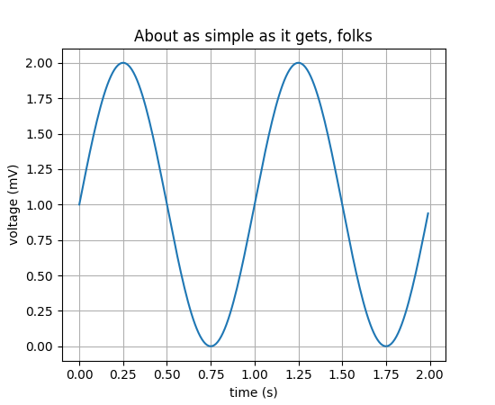

**import** **matplotlib.pyplot** **as** **plt**

**import** **numpy** **as** **np**

t = np.arange(0.0, 2.0, 0.01)

s = 1 + np.sin(2*np.pi*t)

plt.plot(t, s)

plt.xlabel('time (s)')

plt.ylabel('voltage (mV)')

plt.title('About as simple as it gets, folks')

plt.grid(**True**)

plt.savefig("test.png")

plt.show()

**import** **matplotlib.pyplot** **as** **plt**

plt.plot([1,2,3,4])

plt.ylabel('some numbers')

plt.show()

([Source code](https://matplotlib.org/mpl_examples/pyplots/pyplot_simple.py), [png](https://matplotlib.org/mpl_examples/pyplots/pyplot_simple.png), [pdf](https://matplotlib.org/mpl_examples/pyplots/pyplot_simple.pdf))

